Q1.Give commands for the following

1. To run a shell script “merge.sh” at the background

COMMAND: sh merge.sh &



2.To find out lines which contains ‘^M’ characters at the end of everyline of the file called sample.txt

COMMAND: grep ‘\^M$’ sample.txt

OUTPUT:

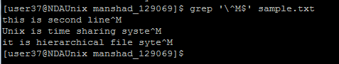

3.To sort a pipe de-limited file as per its third column

COMMAND: sort –t “|” –k3 emp2

OUTPUT:

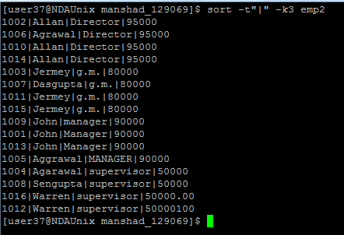

Q2. Wtite shell script for the following:

4. Write a program to accept the filename from the user and check whether the file exists,is readable and has non zero size. If the fie is available show the following details

File created by

Date and time of creation

Size of file

Do all the validation and produce output of each validation

COMMANDS

$ vi file.sh

echo “read filename”

If test –r $filename –a –s $filename

Then

echo “ file created by”: ls –l 4 $filename | cut –d “ “ –f3

echo “file date & time of creation “: ls –ls filename | cut –d “ “ –f 6-9

echo “size of the file is “: ls –l $filename |cut –d “ “ –f5

fi

OUTPUT:

